Phase 2 · Develop
Exercise 4: The Data Layer: SQL Schema and ORM Models
Dev cycle | Develop (data)
CC features | The build loop, @file references, running code to validate, targeted single-file edits
Time | 35 min
You produce | Working app/db.py and app/models.py that create the SQLite schema

Objective
Build the foundation: the database. You will run the Claude Code build loop for the first time (prompt, Claude writes, you run, you correct) and learn to validate every step by actually executing the code rather than trusting the output.
Walk-through
1 | Generate the database wiring
Ask for the SQLAlchemy engine, session, and base, plus a function that creates tables. Reference the architecture so Claude builds to the agreed plan.
Type this prompt into Claude Code
Implement app/db.py per @docs/ARCHITECTURE.md and @CLAUDE.md: a SQLAlchemy engine on SQLite (expenseflow.db), a SessionLocal factory, a Base, a get_db dependency for FastAPI, and an init_db() that creates all tables. Type hints throughout.
VALIDATE Claude proposes app/db.py and asks permission. Read the diff: engine points at sqlite:///expenseflow.db, get_db yields and closes a session in a try/finally. Approve it.
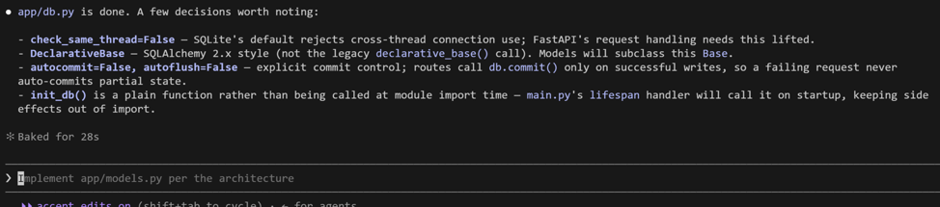

2 | Generate the model
Now the expenses table as an ORM model, honouring the money-as-integer rule from CLAUDE.md.
Type this prompt into Claude Code
Create app/models.py with an Expense model matching the schema in ARCHITECTURE.md. amount_minor and amount_base_minor are integers (paise). status is a string with values pending, approved, rejected, defaulting to pending. created_at defaults to now. Add a CHECK or validation note for status if practical.

VALIDATE

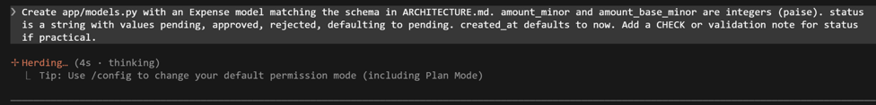
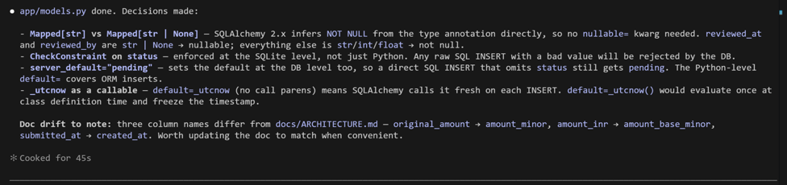
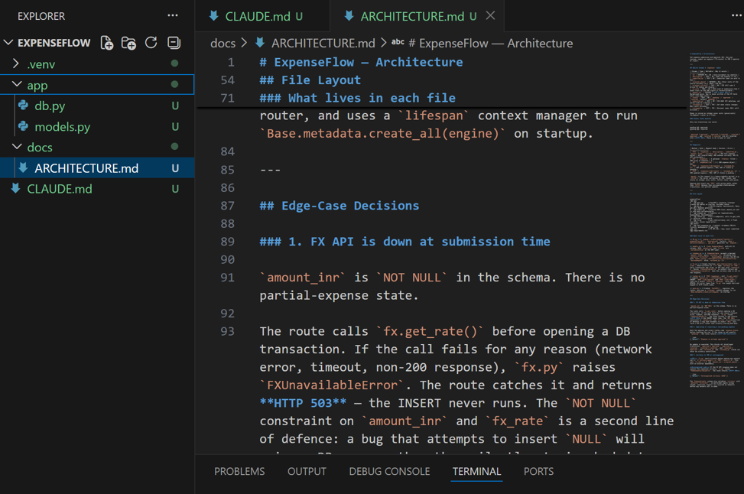
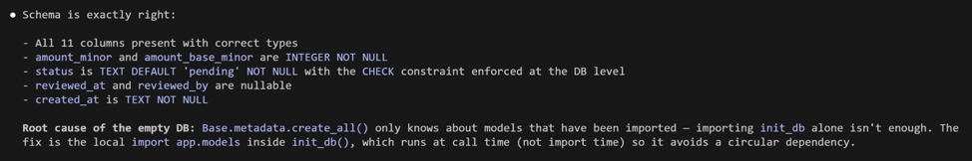

3 | Create the tables and prove it
Code that has not run is a guess. Have Claude give you a one-liner to initialise the database, then run it yourself in PowerShell.

Run in terminal
PS> python -c "from app.db import init_db; init_db(); print('tables created')"

VALIDATE You see 'tables created' and a expenseflow.db file appears in the project. If you get a ModuleNotFoundError for app, add an empty app/__init__.py (ask Claude to do it) and re-run.

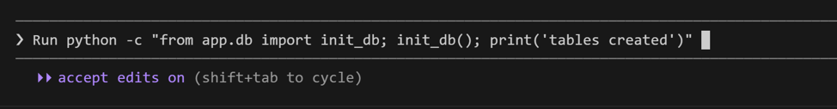
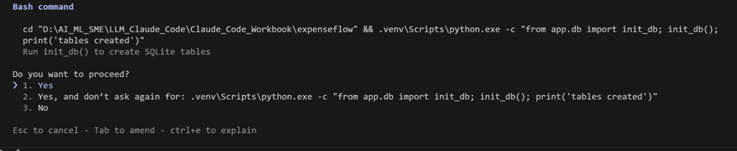

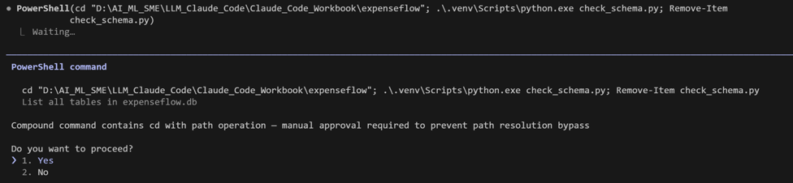
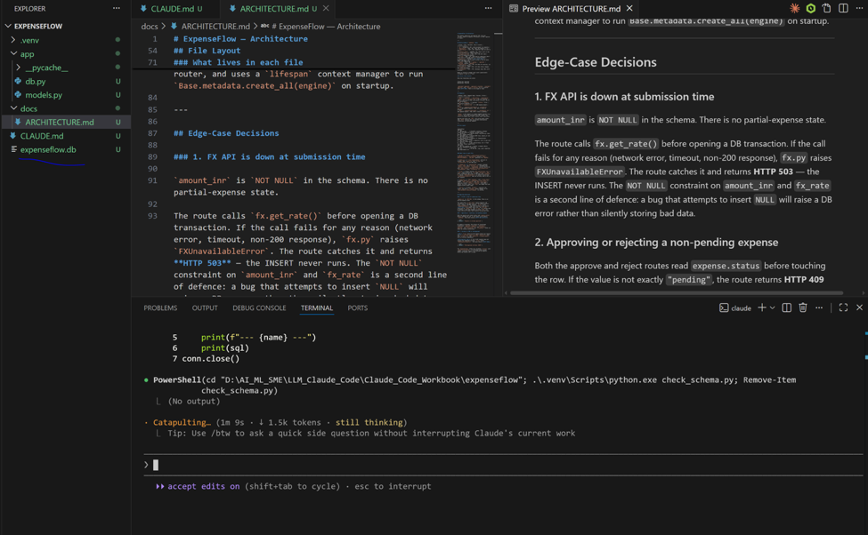
4 | Inspect the real schema
Trust, then verify. Confirm the table that was actually created matches what you designed, not what Claude said it created.
python -c "import sqlite3,os; c=sqlite3.connect('expenseflow.db'); print(c.execute(\"SELECT sql FROM sqlite_master WHERE name='expenses'\").fetchone()[0])"
Run in terminal
PS> python -c "import sqlite3,os; c=sqlite3.connect('expenseflow.db'); print(c.execute(\"SELECT sql FROM sqlite_master WHERE name='expenses'\").fetchone()[0])"
VALIDATE The printed CREATE TABLE statement contains amount_minor and amount_base_minor as INTEGER, a status column, and created_at. This is ground truth from the database itself.
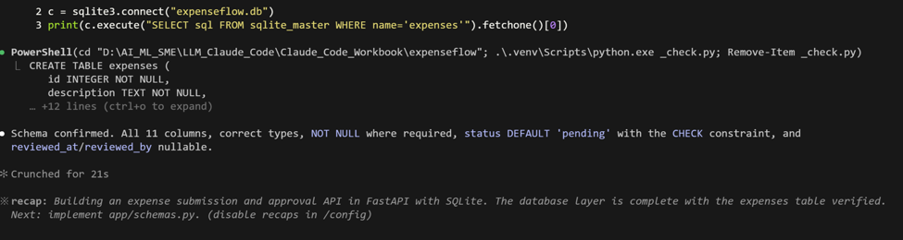

What success looks like
- expenseflow.db exists and contains an expenses table whose columns match your architecture.
- You validated the schema by querying the database directly, not by reading Claude's summary.
- Money columns are integers, as CLAUDE.md demands.
Common pitfalls (Windows and macOS)
- The double-quote escaping in step 4 matters in PowerShell. If it errors, ask Claude: 'give me a PowerShell-safe one-liner to print the expenses table schema'.
- If imports fail, the usual cause is a missing app/__init__.py or running from the wrong directory. Stay in the project root.
Stretch goal
Ask Claude to add a tiny scripts/seed.py that inserts three sample expenses, then run it and query the row count. You now have data to work with in the next exercise.

